Functional Requirements Document
Template

TITLE: Still a work in process…
Team name: Group07
Team members: Jacob Chapman, William Peers, Jingkang Yang

GitHub URL: https://github.com/Jacobchapman99/ENSE-374-Group07-Project

Version | Description of Change | Author | Date
3 | Section 1 | Team Group07 | October 2, 2019

CONTENTS
1 INTRODUCTION 4
1.1 Purpose 4
1.2 Scope 4
1.3 Background 4
1.4 References 4
1.5 Assumptions and Constraints 4
1.6 Document Overview 5
2 METHODOLOGY 5
3 FUNCTIONAL REQUIREMENTS 5
4.1 Context 5
4.2 User Requirements 5
4.3 Data Flow Diagrams 6
4.4 Logical Data Model/Data Dictionary 6
4.5 Functional Requirements 6
5 OTHER REQUIREMENTS 6
5.1 Interface Requirements 6
5.2 Data Conversion Requirements 7
5.3 Hardware/Software Requirements 7
5.4 Operational Requirements 7
APPENDIX A - GLOSSARY 11

INTRODUCTION
The application we are hoping to create will hopefully engage the class in a fun activity that will stimulate the brain and have a fun time. We are creating a web based video game that takes the concept of a card flip memorization game. It is called “MatchYourProfessor”, where the cards will have engineering professor’s heads on them and the user must match them. The interface has features for the user to engage with, such as manipulating the cards shown to the user as part of the main game, choose which size of deck they want to have depending on level of difficulty, and keep track of how many consecutive flips they got correct. This interface will include a database consisting of engineering professors from the University of Regina.

Purpose
The FRD will allow us to flesh out all the necessary requirements in order to successfully create this application. The FRD will list all the requirements, constraints, limitations, sources, etc. all in one document for easy access and understanding.

Scope
The scope of this document covers both the design process and the creation of this application.

Background
We as students want to have a stress reliever when studying. We want to enjoy ourselves while also having stimulating brain activity. We decided that we would create a video game based off our interest as students studying too much and wanting a break every now and then. As well, we want to put our skills to good practice to get a better understanding of what we are currently learning.

References

Assumptions and Constraints
- Beginner abilities in web design
- Time frame is ~ 2 months
- Domain will be under Hercules server

Assumptions
We assumed that there is no application like this that will create copyright issues. We also assumed that the eclipse platform will be available for us to use and will be sufficient for completing the application. We also assumed that the java language will create our envisioned functionality for the application along with JavaScript.

Constraints
- We all have a limited amount of experience coding with java and JavaScript
- We are limited by time in multiple ways. We have a short amount of time to complete the full project. We also have limited time to meet due to busy schedules.
- We have never designed or created a model-view controller before

Document Overview

METHODOLOGY
For this application, the approach chosen to model our design was to use UML Class diagrams, Data Flow charts, and Sequence diagrams to show how the user will interact with the purposed video game.

FUNCTIONAL REQUIREMENTS

Context
Our system contains many features with many to many relationships that are required for the system to function properly. The sign-up page requires the user to navigate to it and enter information which will then be stored into a relative database. The Log in Information pulls data from a database and is then used within the system. Our system also has Github implemented so that users can view our team members, and it pulls necessary information from the Github so that it can be displayed on the website. The high score page gets data from the system to display in the page itself, as well, it puts data into the page from the system so that users can look back and see their high scores. The U of R professor webpage allows the website to retrieve necessary information for the user to interact with, and our website will allow users to navigate to the page to see professor details. The U of R webpage allows us to access any other relevant information.

Exhibit 2 - Generic Context Diagram
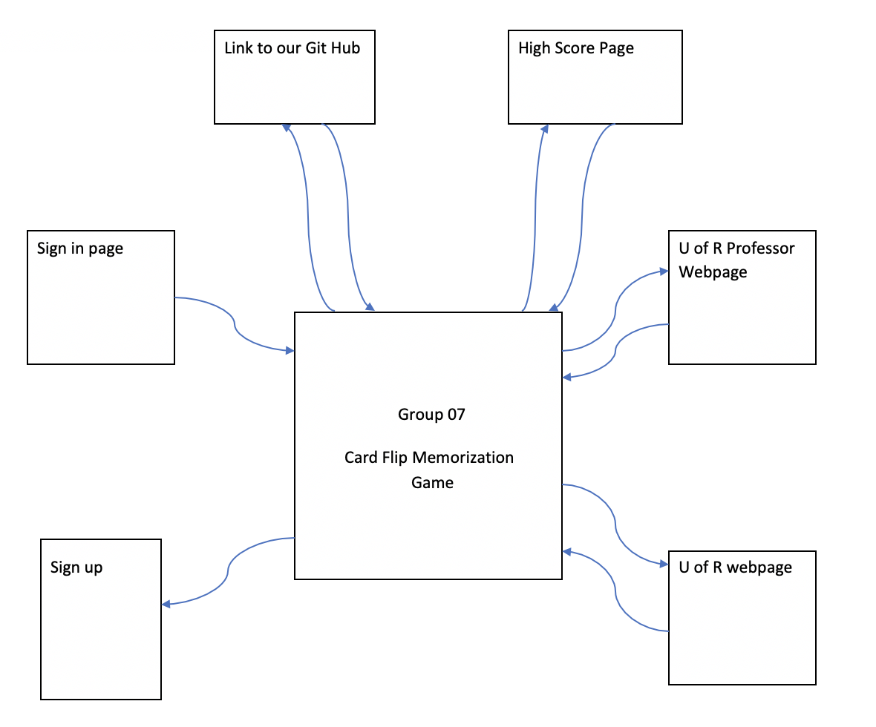

User Requirements
When accessing the main page, the user is able to play the game with or without signing in. If a user signs in, they are able to access their high score page which will display all their high scores from previous dates. A user who has signed in or not signed in is able to view the creators GitHub, as well as view the database of professors who are used within the application. A user who is not signed in can play the game, however no information will be saved under any circumstances.

Data Flow Diagrams
[Decompose the context level diagrams to determine the functional requirements. Data flow diagrams should be decomposed down to the functional primitive level. These diagrams are further decomposed during design.]

Logical Data Model/Data Dictionary
[Create the initial Logical Data Model. Describe data requirements by providing data entities, decomposition, and definitions in a data dictionary. The data requirements describe the business data needed by the application system. Data requirements do not describe the physical database and are not at the level of identifying field names.]

Functional Requirements
[List the functional requirements of the system.]

Functional Requirements Group 1
[List the functional requirements for each functional requirements group.]
Exhibit 4 - Sample Requirements Group 1
Section/ Requirement ID | Requirement Definition
FR1.0. | The system shall [parent requirement group 1].
FR1.1 | The system shall [child/parent requirement].
FR1.1.1 | The system shall [child requirement].
FR1.1.2 | The system shall [child requirement].

Functional Requirements Group 1, Etc.

OTHER REQUIREMENTS
[Describe the non-behavioral requirements.]

Interface Requirements
[Describe the user interfaces that are to be implemented by the system.]

Hardware Interfaces
[Define hardware interfaces supported by the system, including logical structure, physical addresses, and expected behavior.]

Software Interfaces
[Name the applications with which the subject application must interface. State the following for each such application: name of application, external owner of application, interface details (only if determined by the other application).
It is acceptable to reference an interface control document for details of the interface interactions.]

Communications Interfaces
[Describe communications interfaces to other systems or devices, such as local area networks.]

Data Conversion Requirements
[Describe the requirements needed for conversion of legacy data into the system.]

Hardware/Software Requirements
[Provide a description of the hardware and software platforms needed to support the system.]

Operational Requirements
[Provide the operational requirements in this section.
Do not state how these requirements will be satisfied. For example, in the Reliability section, answer the question, “How reliable must the system be”? Do not state what steps will be taken to provide reliability.
Distinguish preferences from requirements. Requirements are based on business needs, preferences are not. If, for example, the user requires a special response but does not have a business-related reason for it, that requirement is a preference.
Other applicable requirements on system attributes may be added to the list of subsections below.]
Operational requirements describe how the system will run and communicate with operations personnel.

Security and Privacy
[Provide a list of the security requirements using the following criteria:
A. State the consequences of the following breaches of security in the subject application:
- Loss or corruption of data
- Disclosure of secrets or sensitive information
- Disclosure of privileged/privacy information about individuals
- Corruption of software or introduction of malware, such as viruses
- State the type(s) of security required. Include the need for the following as appropriate:
- Physical security.
- Access by user role or types.
- State access control requirements by data attribute. For example, one group of users has permission to view an attribute but not update it while another group of users has permissions to update or view it.
- State access requirements based on system function. For example, if there is a need to grant access to certain system functions to one group of users, but not to another. For example, "The system shall make Function X available to the System Administrator only".
- State if there is a need for certification and accreditation of the security measures adopted for this application]
The Security Section describes the need to control access to the data. This includes controlling who may view and alter application data.

Audit Trail
[List the activities recorded in the application’s audit trail. For each activity, list the data recorded.]

Reliability
A. [State the following in this section:
- State the damage can result from failure of this system—indicate the criticality of the software, such as:
- Loss of human life
- Complete or partial loss of the ability to perform a mission-critical function
- Loss of revenue
- Loss of employee productivity
- What is the minimum acceptable level of reliability?
B. State required reliability:
- Mean-Time-Between-Failure is the number of time units the system is operable before the first failure occurs.
- Mean-Time-To-Failure is the number of time units before the system is operable divided by the number of failures during the time period.
- Mean-Time-To-Repair is the number of time units required to perform system repair divided by the number of repairs during the time period.]
Reliability is the probability that the system processes work correctly and completely without being aborted.

Recoverability
[Answer the following questions in this section:
A. In the event the application is unavailable to users (down) because of a system failure, how soon after the failure is detected must function be restored?
B. In the event the database is corrupted, to what level of currency must it be restored? For example “The database must be capable of being restored to its condition of no more than 1 hour before the corruption occurred”.
C. If the processing site (hardware, data, and onsite backup) is destroyed, how soon must the application be able to be restored?]
Recoverability is the ability to restore function and data in the event of a failure.

System Availability
[State the period during which the application must be available to users. For example, “The application must be available to users Monday through Friday between the hours of 6:30 a.m. and 5:30 p.m. EST. If the application must be available to users in more than one time zone, state the earliest start time and the latest stop time. Consider daylight savings time, too.
Include use peak times. These are times when system unavailability is least acceptable.]
System availability is the time when the application must be available for use. Required system availability is used in determining when maintenance may be performed.

General Performance
[Describe the requirements for the following:
A. Response time for queries and updates
B. Throughput
C. Expected rate of user activity (for example, number of transactions per hour, day, or month, or cyclical periods)
Specific performance requirements, related to a specific functional requirement, should be listed with that functional requirement.

Capacity
[List the required capacities and expected volumes of data in business terms. Do not state capacities in terms of system memory requirements or disk space—if growth trends or projections are available, provide them]

Data Retention
[Describe the length of time various forms of data must be retained and the requirements for its destruction.
For example, “The system shall retain application information for 3 years”. Different forms of data include: system documentation, audit records, database records, access records.]

Error Handling
[Describe system error handling.]

Validation Rules
[Describe System Validation Rules.]

Conventions/Standards
[Describe system conventions and standards followed.
For example: Microsoft standards are followed for windows, Institute of Electrical and Electronics Engineers (IEEE) for data formats, etc.]

APPENDIX A - GLOSSARY
[Define terms, acronyms, and abbreviations used in the FRD.]

